HCCDA – Tech Essentials Exam
Huawei Cloud Service Certification for Beginners.
Exam Instructions
After you start the exam, the platform automatically starts recording the exam desktop for score tracing.
1.1. Operation Guide
During the exam, you can click the arrow on the left of the exercise operation interface to hide the tutorials, and click the Full Screen icon in the upper right corner to enable the full-screen mode.
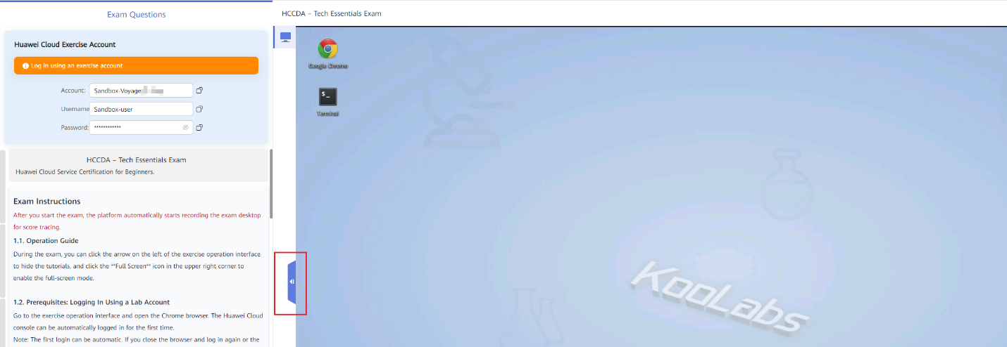
1.2. Prerequisites: Logging In Using a Lab Account
Go to the exercise operation interface and open the browser. The Huawei Cloud console can be automatically logged in for the first time.
Note: The first login can be automatic. If you close the browser and log in again or the automatic login fails, perform the following steps: Click IAM User. In the login dialog box, enter the Huawei Cloud lab account and password allocated by the system to log in to Huawei Cloud, as shown in the following figure.
Attention:
Do NOT use your personal Huawei Cloud account.
Using a personal account does not earn points, and the consumed resource fees are non-refundable.
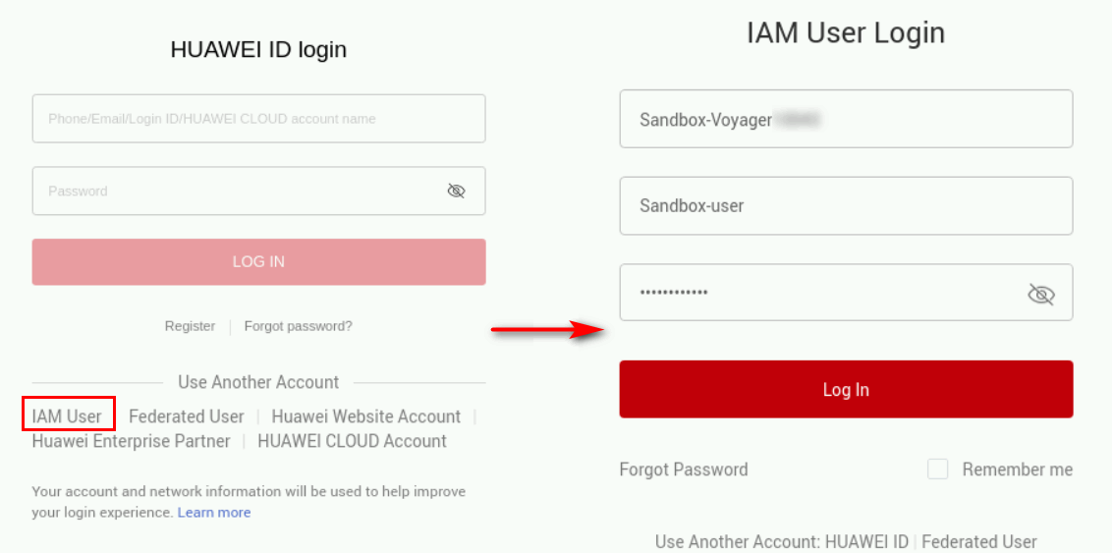
2. Exercise Tests
Exercise duration: 90 minutes
A. Obtain resources by yourself during the exercise.
B. When purchasing cloud services, select the pay-per-use billing mode and follow the task requirements on resource specifications. Otherwise, no point will be given.
C. Do not purchase yearly/monthly-billed resources or resources of specifications that do not meet the task requirements. Otherwise, the purchased resources will be automatically deleted.
D. All resources must be purchased in AP-Singapore. Otherwise, the purchased resources will be automatically deleted.
E. This exam consists of three exercises.
Exercise 1: Basic Network Configuration and Cloud Resource Purchase
Task 1: Creating a VPC and subnet, and configuring a security group（5 points）
Objective: Correctly create a VPC subnet in the specified CIDR block and security group.
Some parameters of VPC, subnet, and security group are as follows:
Region: AP-Singapore
Name: vpc-test
IPv4 Network Segment: 192.168.0.0/16
Subnet Name: subnet-test
IPv4 CIDR Block: 192.168.2.0/24
Security Group: sg-test
Task 2: Purchasing and logging in to an ECS（5 points）
Objective: Purchase and log in to an ECS.
Some ECS parameters are as follows:
Billing Mode: Pay-per-use
Region: AP-Singapore
AZ: Random or specified
Specifications: s6.large.2 (If sold out,please replace AZ)
Image: Huawei Cloud EulerOS 2.0 Standard 64 bit
System Disk: High I/O, 40 GiB
Add Data Disk: High I/O, 40 GiB
Protection: None
VPC: vpc-test
Security Group: sg-test(You need to create a security group and enable the corresponding port for subsequent operations.)
EIP: Auto assign
EIP Type: Dynamic BGP
Billed By: Traffic
Bandwidth Size: 5 Mbit/s
ECS Name: ecs-test
Login Mode: Password
Other parameters: Default
Quantity: 1
Task 3: Installing Apache and creating an image（10 points）
Objective: A private image is successfully created using the ECS with httpd installed.
Tips:
1. SSH login command:
Copy Codessh root@EIP
2. Run the following command to download the service:
Copy Codeyum -y install httpd
3. Run the following command to enable the service on each ECS:
Copy Codesystemctl start httpd
4. Run the following command to set httpd to start at boot:
Copy Codesystemctl enable httpd
5. Configure the image parameters as follows:
Image Type：System disk image
Source: ECS
ECS: ecs-test
Name: image-test
Exercise 2: Storage Cloud Services
Task 1: Purchasing and mounting an EVS disk
Objective: Purchase and mount an EVS disk successfully.
Tips:
Purchase an EVS disk (disk name: volume-test, high I/O,10 GB) and mount the data disk to an ECS. Note that the AZ of the data disk must be the same as that of the Linux ECS.
Procedure:
Step 1 Remotely log in to the Linux ECS and run the following command to view the new data disk:
Copy Codefdisk -l
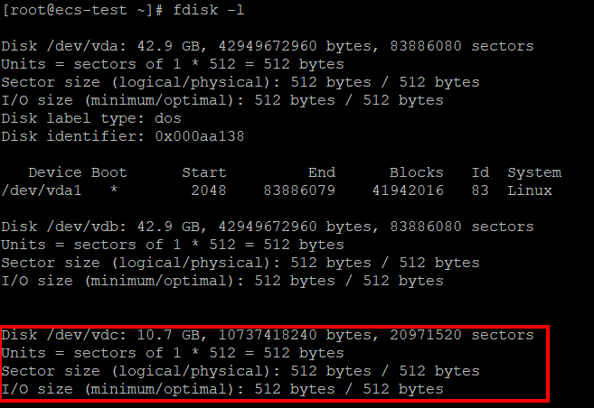
In the command output, the ECS contains two disks: /dev/vda is the system disk and /dev/vdb is the data disk. /dev/vdc is the data disk created in this step.
Step 2 Run the following command to use fdisk to partition the added data disk:
In this example, run the following command:
Copy Codefdisk /dev/vdc
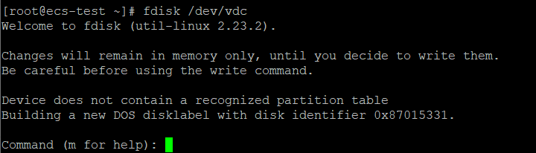
Enter n and press Enter to create a partition.
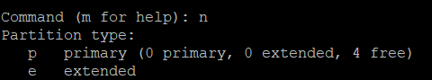
Step 3 In this example, a primary partition is created. Enter p and press Enter to create a primary partition.
Enter the serial number of the primary partition and press Enter. Partition number 1 is used in this example.

First sector indicates the start sector. The value ranges from 2048 to 20971519, and the default value is 2048.
Step 4 Select 2048 and press Enter. (The default first sector 2048 is used in this example.)
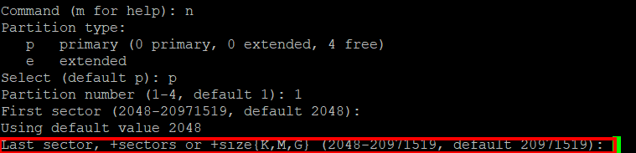
Last sector indicates the end sector. The value ranges from 2048 to 20971519, and the default value is 20971519.
Step 5 Select 20971519 and press Enter. (The default last sector 20971519 is used in this example.)
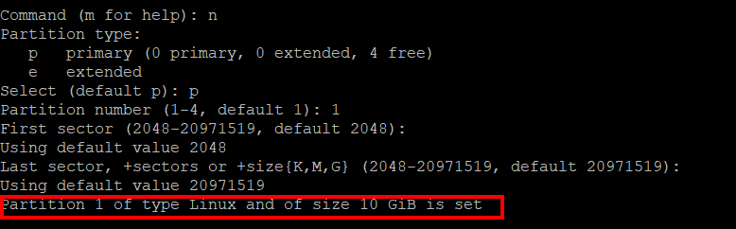
A primary partition has been created for a 10 GB data disk.
Step 6 Enter p and press Enter to view the details about the created partition.
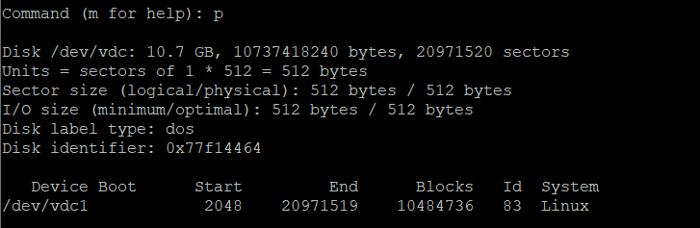
Details about the /dev/vdb1 partition are displayed.
Step 7 Enter w and press Enter to write the partitioning result into partition tables.
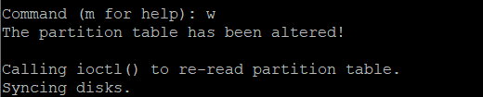
In case that you discard the changes made before, you can exit fdisk by entering q.
Step 8 Run the following command to synchronize the new partition table to the OS:
Copy Codepartprobe
Step 9 Run the following command to set the required format for the file system of the newly created partition:
mkfs -t 'File system format' /dev/vdc1
In this example, run the following command to set the ext4 file system for the new partition:
Copy Codemkfs -t ext4 /dev/vdc1
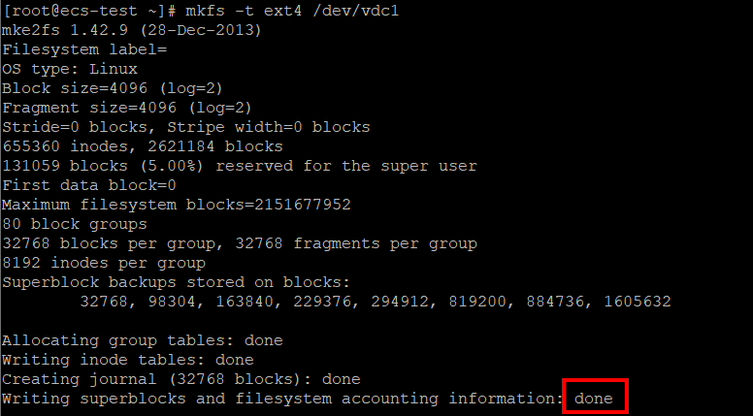
The formatting takes a period of time. Wait until the task status changes to done.
Step 10 Create a mounting point.
In this example, run the following command to create a mounting point /mnt/sdc:
Copy Codemkdir /mnt/sdc
Step 11 Mount the new partition to the mounting point created in the previous step.
In this example, run the following command to mount the new partition on /mnt/sdc:
Copy Codemount /dev/vdc1 /mnt/sdc
Step 12 View the mounting result.（10 points）
Copy Codedf -TH
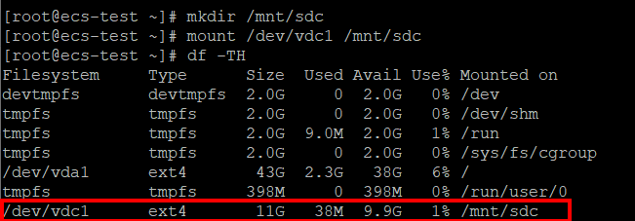
New partition /dev/vdc1 has been mounted to /mnt/sdc.
Task 2: Creating an OBS bucket and storing a file in the bucket（10 points）
Objective: The bucket is successfully created and the file obs-test.txt is successfully uploaded to the bucket.
Tip:
1. Create a text file obs-test.txt on the local PC.
2. Details about some OBS bucket parameters:
Region: AP-Singapore
Bucket Name: hw-User-defined (Note: The bucket name must start with hw-.)
Data Redundancy Policy: Multi-AZ storage
Default Storage Class: Standard
Bucket Policy: Private
Exercise 3: ELB
Task 1: Implementing load balancing（10 points）
Objective: When you refresh the browser, you can see that the page comes from three servers in turn, achieving load balancing.
Tips:
1. Use the private image image-test created in exercise 1 to create two ECSs with the same specifications as ecs-test. No additional disks are required. Create three index.html files in the default Apache directory of the three ECSs. The content of the files is SERVER1, SERVER2, and SERVER3.
2. Run the following command to check whether httpd is enabled:
Copy Codeps -ef | grep httpd
3. Port 8889 must be enabled.
4. The ELB load balancer specifications are as follows:
Type: Shared
Region: AP-Singapore
Network Type: Public IPv4 network
VPC: VPC-test
EIP: New EIP; EIP Type: Dynamic BGP; Billed by: Bandwidth; Bandwidth: 1 Mbit/s
Name: elb-test
5. Configure the listener as follows:
Name: Enter a name.
Frontend Protocol/Port: TCP/8881
Redirect: Retain the default value.
6. Configure the backend server group as follows:
Backend Cloud Server Group: Create new
Name: server_group-test
Load Balancing Algorithm: Weighted round robin
Health Check: Enabled, TCP, 8889
7. In the address box of the local browser, enter the load balancer port link (http://ELB EIP:8881) to check whether the service can be accessed. You can view the EIPs in the load balancer list on the ELB console and locate the EIP of the load balancer you created. When the page is refreshed, the ECSs where SERVER1, SERVER2, and SERVER3 are created are accessed.
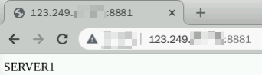
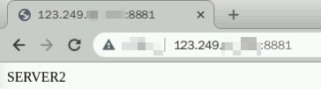
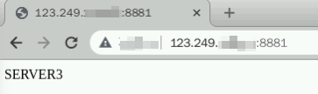
3. Exercise Reminder
A. All behaviors during the exam will be recorded. If there is any violation, you will be disqualified or the exam result will be invalidated.
B. If you have any questions about the exam platform during the exam, send a private message to the exam supervisor.
C. After you click Submit, all configurations and operations cannot be modified. Please check your exercise procedure carefully before submission.
D. 48 hours after passing the exam, you can go to Personal Center >My Developer Certification to check the certificate number and download the certificate.

